LIBERTY VARSITY WRESTLING
2011 – 2012

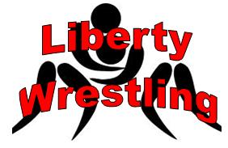
Day Date Time Opponent Location
Sat 12/10 9:00 AM Mamaroneck Tournament Mamaroneck HS
Sat 12/17 9:00 AM Cuneen-Doan Tournament Walton HS
Wed 12/21 6:00 PM Liberty Highland HS
Wed 1/4 5:00 PM Chester Academy Tri Valley HS
Wed 1/4 7:00 PM Tri Valley Tri Valley HS
Wed 1/11 5:00 PM Millbrook New Paltz HS
Wed 1/11 6:00 PM New Paltz New Paltz HS
Fri 1/13 10:00 AM Eastern States Classic Sullivan CC
Sat 1/14 10:00 AM Eastern States Classic Sullivan CC
Wed 1/18 5:00 PM Red Hook Tuxedo HS
Wed 1/18 7:00 PM Tuxedo Tuxedo HS
Sat 1/21 9:00 AM Marathon Open Marathon HS
Wed 1/25 5:00 PM Burke Catholic Liberty HS
Wed 1/25 6:00 PM Ellenville Liberty HS
Wed 2/1 5:00 PM Fallsburg Liberty HS
Wed 2/1 6:00 PM Onteora Liberty HS
Sat 2/4 9:00 AM JV Sectionals Warwick HS
Sun 2/12 9:00 AM Section 9 Tournament Rondout Valley
Fri 2/24 9:00 AM NYS Championships Times Union Center, Albany
Sat 2/25 9:00 AM NYS Championships Times Union Center, Albany

** For up-to-date results go to www.sectionixwrestling.com**

