MINISINK VALLEY WRESTLING 2011 – 2012 SCHEDULE
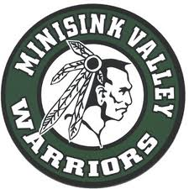

Day Date Time Opponent Location Tue 12/06 6:30 Section 9 Duals Middletown HS
Wed 12/07 5:30 Section 9 Duals NFA High School
Sat 12/10 9:00 Colonie Tournament Colonie HS
Sun 12/11 9:00 Colonie Tournament Colonie HS
Wed 12/14 6:30 Wallkill Minisink Valley HS
Thu 12/15 7:00 Valley Central Valley Central HS
Sat 12/17 9:00 Jim Wilson Duals Minisink Valley HS
Wed 12/21 7:00 Saugerties Saugerties HS
Tue 12/27 9:00 Cougar Classic Kittatiny HS (NJ)
Wed 1/04 6:30 Port Jervis Minisink Valley HS
Sat 1/07 9:00 UE Duals Union Endicott HS
Sun 1/08 9:00 UE Duals Union Endicott HS
Tue 1/10 7:00 Washingtonville Washingtonville HS
Fri 1/13 9:30 Eastern States Sullivan County CC
Sat 1/14 9:30 Eastern States Sullivan County CC
Wed 1/18 6:30 Cornwall Minisink Valley HS
Thu 1/19 5:30 Goshen Minisink Valley HS
Sat 1/21 9:00 Gene Brigham Tourney Minisink Valley HS
Wed 2/01 7:00 Monticello Monticello HS
Fri 2/03 7:00 Warwick Warwick HS
Fri 2/10 5:00 Section 9 Championship Monroe Woodbury
Sat 2/11 10:00 Section 9 Championship Monroe Woodbury
Fri 2/24 10:00 NYS Championships Times Union, Albany
Sat 2/25 10:00 NYS Championships Times Union, Albany
Get up-to-date results at www.sectionIXwrestling.com

