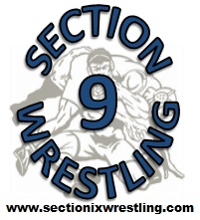
Week of 1/2/12 thru 1/8/12
Duals:
Tuesday - Goshen @ Cornwall
Wednesday
- Liberty & Chester@ Tri-Valley
- Burke & Millbrook @ Rondout Valley
- Onteora & Tuxedo @ Ellenville
- Red Hook & Eldred/Fallsburg @ New Paltz
- Washingtonville @ Monticello
- Port Jervis @ Minisink Valley (alumni night for MV….6:30 start)
- VC @ NFA
- MW @ PB
- Wallkill @ Cornwall
- Goshen @ Saugerties
Thursday
- Middletown @ Monticello
- Washingtonville @ VC
- Pine Bush @ Wallkill
Tournaments:
- UE Duals (Saturday and Sunday)… Warwick, Monroe Woodbury, and Minisink Valley
- Middie Duals (Friday & Saturday)… Middletown, Cornwall, Port Jervis
- Russ Cordell Tournament in Oneonta…Saugerties, Eldred/Fallsburg (3 wrestlers)
- Roy C. Ketcham Invitational …Goshen
- Ravena Tournament … Onteora

