Minisink Valley Wrestling  "The Warriors"  Head Coach - Kevin Gallagher  Assistant Coach - Scott Hendershot | 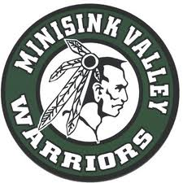

2012-2013 Schedule
Day Date Time Opponent & Location
Tue 12/4 5:00 Section 9 Duals @ NFA
Wed 12/5 5:30 Section 9 Duals @ MW High School
Sat 12/8 9:00 Colonie Tournament @ Colonie HS
Sun 12/9 9:00 Colonie Tournament @ Colonie HS
Wed 12/12 7:00 Washingtonville @ Minisink
Sat 12/15 9:00 Jim Wilson Duals @ Minisink
Wed 12/19 7:00 Valley Central @ Minisink
Thu 12/27 9:00 Cougar Classic @ Kittatinny, NJ
Thu 1/3 7:00 Minisink @ Cornwall HS
Sat 1/5 9:00 UE Duals @ Union Endicott HS
Sun 1/6 9:00 UE Duals @ Union Endicott HS
Wed 1/9 7:00 Minisink @ Wallkill
Fri 1/11 10:30 Eastern States Classic @ SUNY Sullivan
Sat 1/12 10:00 Eastern States Classic @ SUNY Sullivan
Tue 1/15 7:00 Minisink @ Warwick
Thu 1/17 7:00 Minisink @ Middletown
Sat 1/19 9:00 Gene Brigham Invitational @ Minisink
Wed 1/30 6:00 Minisink @ Port Jervis HS
Fri 2/1 7:00 Monroe Woodbury @ Minisink
Fri 2/8 4:30 Section 9 Championships @ Monroe Woodbury HS
Sat 2/9 9:30 Section 9 Championships @ Monroe Woodbury HS
Fri 2/22 10:00 NYS Championships @ Times Union Center
Sat 2/23 10:00 NYS Championships @ Times Union Center

