Saugerties Wrestling
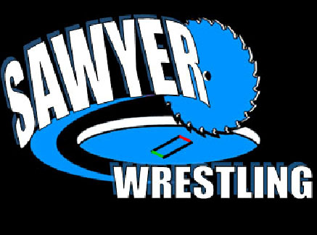
2012 – 2013 Schedule

Date Day Event/Location
12/1-12/2 Sat/Sun Kingston Duals
12/8 Sat JV tournament at Monroe-Woodbury
12/12 Wed Saugerties vs. Port Jervis
12/15 Sat Ravena Duals
12/19 Wed Saugerties vs. Washingtonville
12/22 Sat JV tournament at Washingtonville
12/27- 28 Thu/Fri Mid-Hudson Tournament
1/3 Thur Saugerties @ Walkill
1/4 and 5 Fri/Sat Russ Cordell Rotary @ Oneonta
1/9 Wed Saugerties vs. Cornwall
1/16 Wed Saugerties @ Goshen
1/18-19 Fri/Sat Beacon Tournament
1/25 Fri Saugerties vs. Kingston
1/26 Sat Wizard Duals
1/29 Tue Saugerties @ Monticello
2/8-2/9 Fri/Sat Section 9 Tournament @ Monroe Woodbury
2/22-23 Fri/Sat NYS Tournament @ Times Union Center Albany, NY

