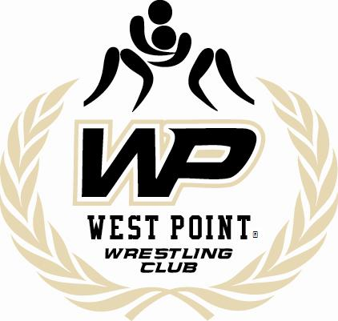

West Point® Wrestling Club
Free Clinic/Meet and Greet, for all ages: On Friday, December 7th
at Arvin Gym, West Point, NY

Grades K – 12: 5:00-6:00 pm
1 Session : Friday, December 7th, 2012

Refreshments will be served after the clinic!!!

Featuring:

Paul Young- Army Assistant Coach, 3x NCAA Qualifier for Indiana University, Ranked as high as 5th nationally, 2x Indiana H.S. State Champ

Enock Francois- Army Volunteer Assistant Coach & Head Club Coach, 3x NAIA All-American including a runner-up finish senior year, still competing at the Senior level in hopes for an Olympic berth in 2016

NCAA D1 Wrestlers

For more information please visit our facebook page and/or website at www.westpointwrestlingclub.org
*DISCLAIMER: This organization is a non-Federal entity organized by individual members of the West Point community. We are not endorsed by the United States Military Academy, United States Army, or Department of Defense.

