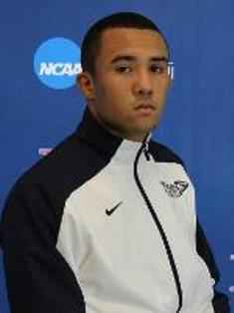
Travis Edwards of Sparrow Bush, NY took 5th place at the King Open on November 23rd. Travis is 165 pound wrestler for NCAA Division 2 King University in Bristol, Tennessee. Wrestling at 165 pounds, Travis had victories over Belmont Abbey's Octavia Rivera (7-4), pin over Cody Richmond of Liberty and a technical fall over Ricky McCarty of Oklahoma City.

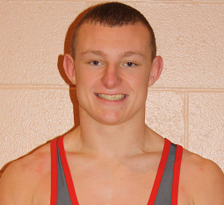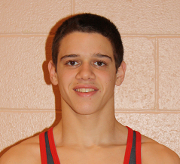

Two Port Jervis alumni competed at the Ted Reese Invitational on December 7th. Sullivan County Community College Dylan Booth earned three victories to win the 125lbs title. Southern Maine’s Dan DeCarlo went 3-1 on the day to place 3rd at the 165lbs.

